Bianca Grobler 600537  
Tiaan Kemp 601223  
Mihir Kumar 601464  
Le-Marsh Vaughan 600857

IOT 281 PROJECT

Contents

Task 1: Smoke detection system. 2

Arduino sketch: 2

Technical Report for Task 1: Smoke Detection System 4

Components used: 4

Schematic view: 5

Task 2: Human detection probe 6

Arduino sketch: 6

Technical Report for Task 2: Human Detection Probe 8

Components used: 8

Schematic view: 9

# Task 1: Smoke detection system.

## Arduino sketch:

* System off.

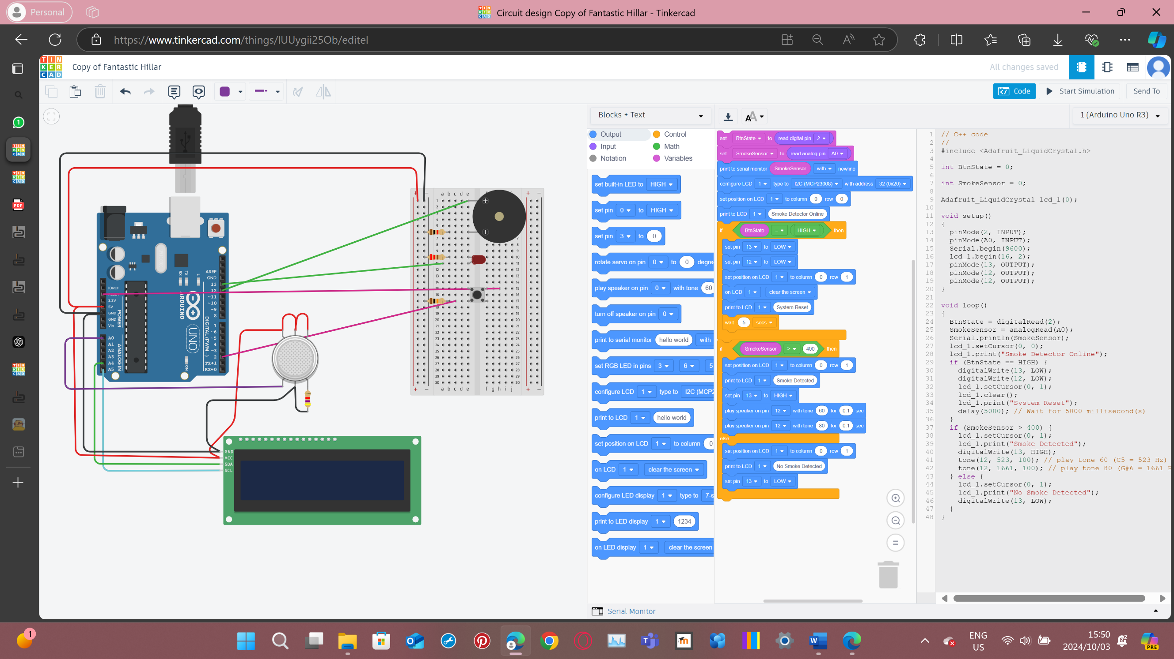

* System on.

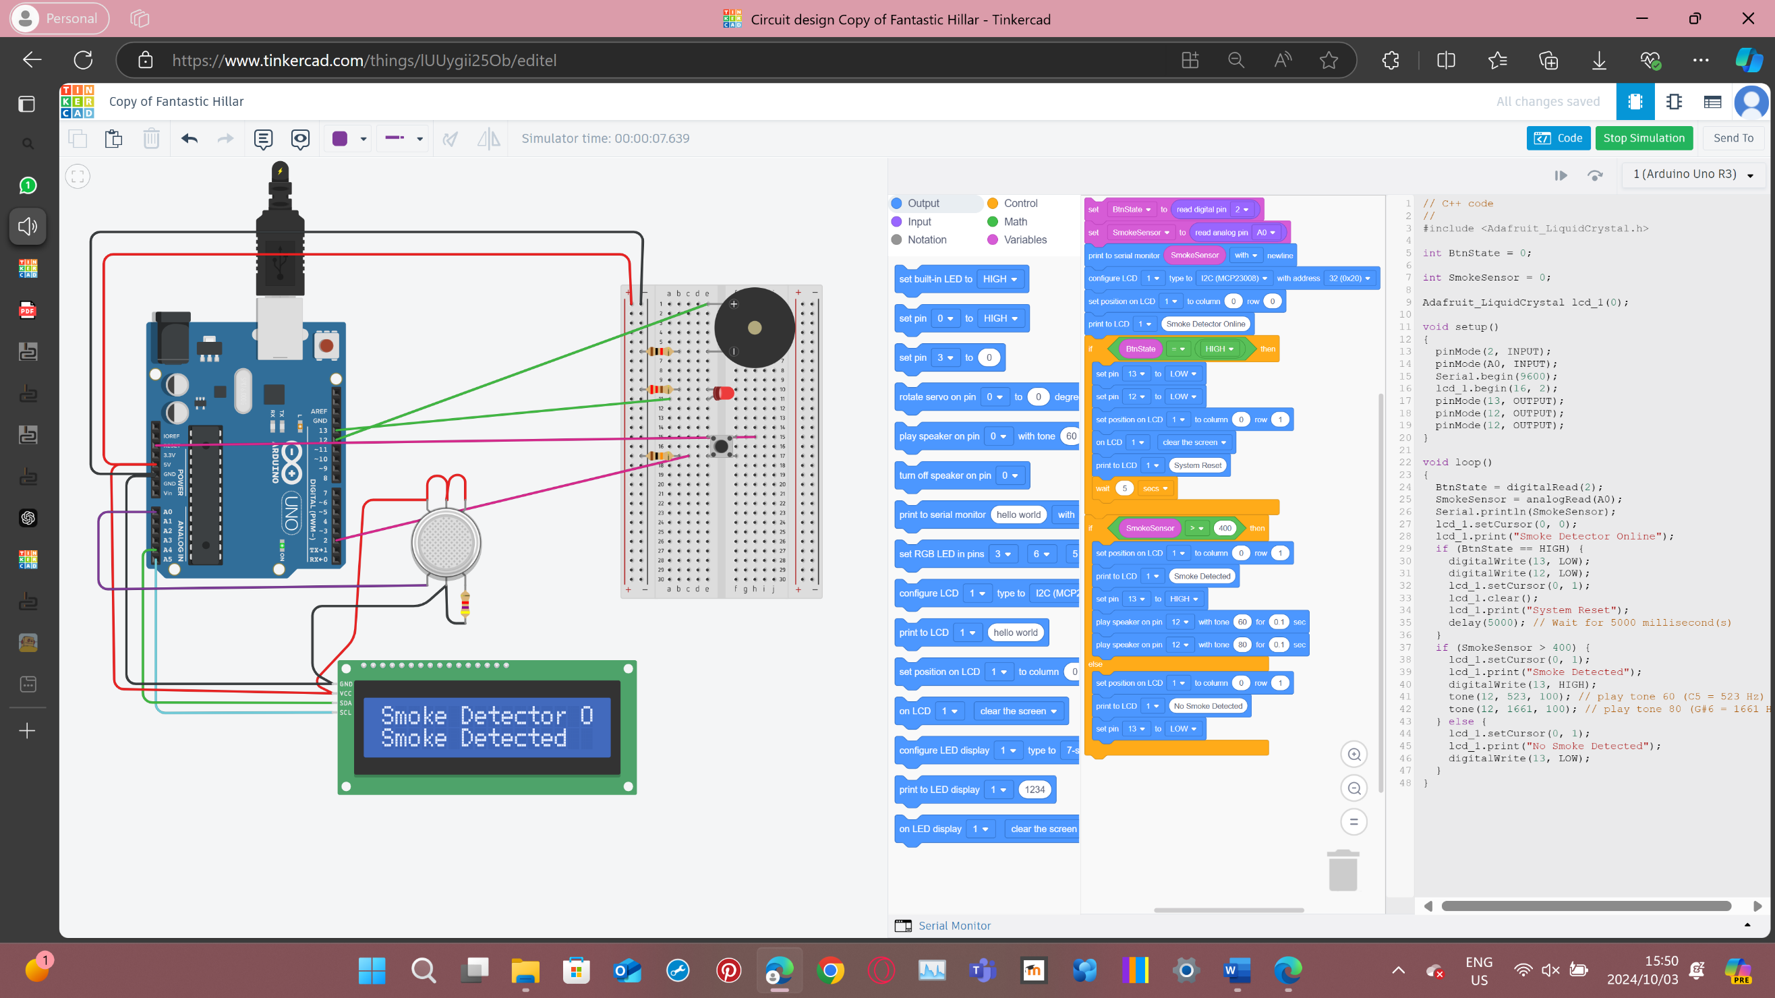

* System resetting.

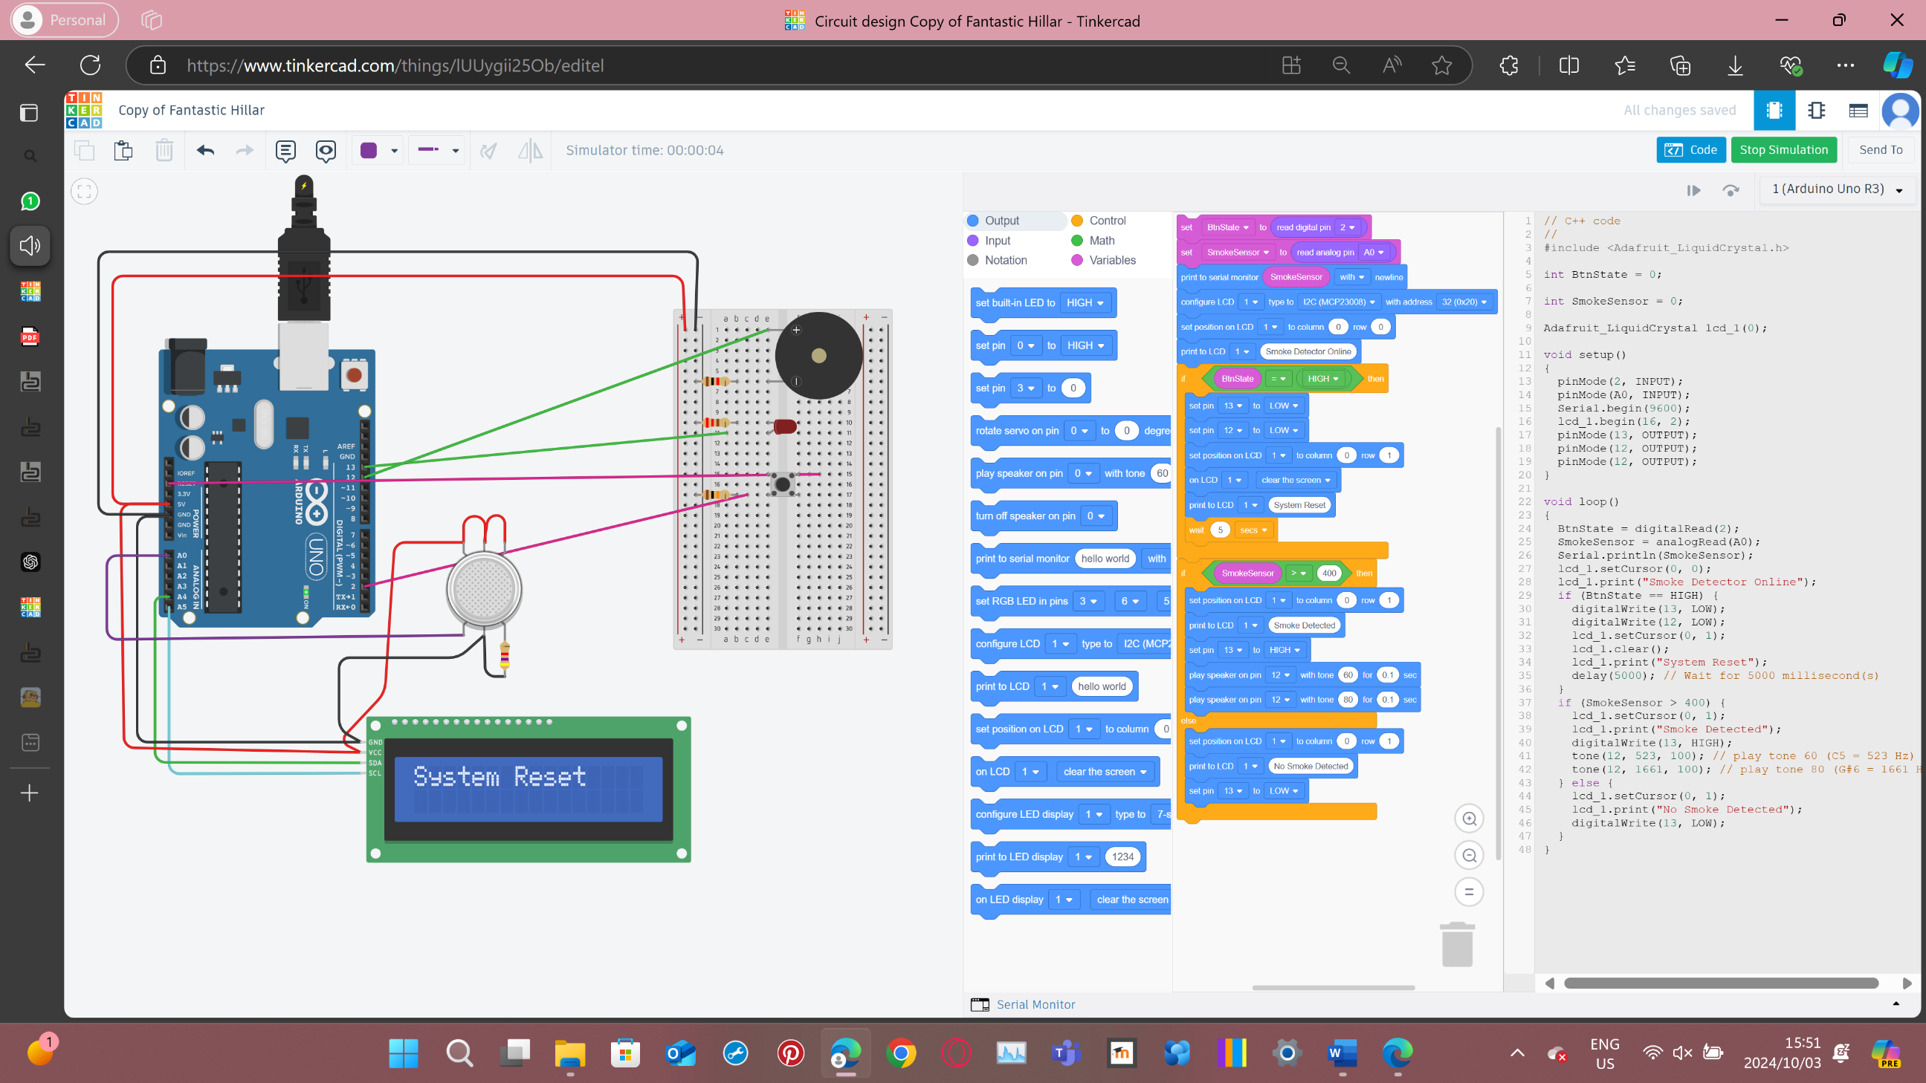

* System code.

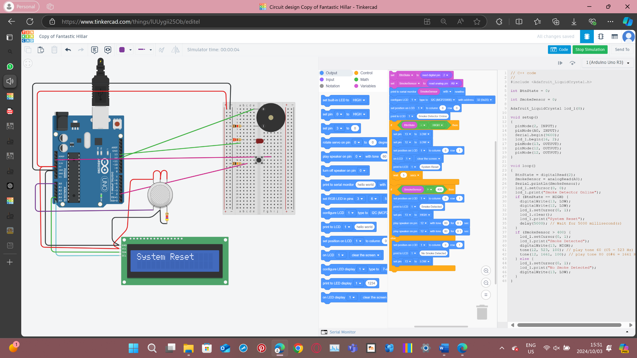

## Technical Report for Task 1: Smoke Detection System

The smoke detection system aims to detect dangerous levels of smoke using an MQ-2 gas sensor. The system provides real-time feedback to the user using a red LED, a piezo buzzer for alarms, and a 16x2 LCD display. The system also includes a reset mechanism with a normally open pushbutton.

### Components used:

* MQ-2 Gas Sensor: Detects smoke and other gases.
* Piezo Buzzer: Emits an audible alarm when smoke is detected.
* Red LED: Provides a visual indication of a hazardous condition.
* 16x2 LCD Display: Displays the status of the system.
* Normally Open Pushbutton: Resets the system after the alarm has been triggered.
* Resistors: Used to limit current to the LED and other components.
* Arduino Uno: Microcontroller used to control all components.

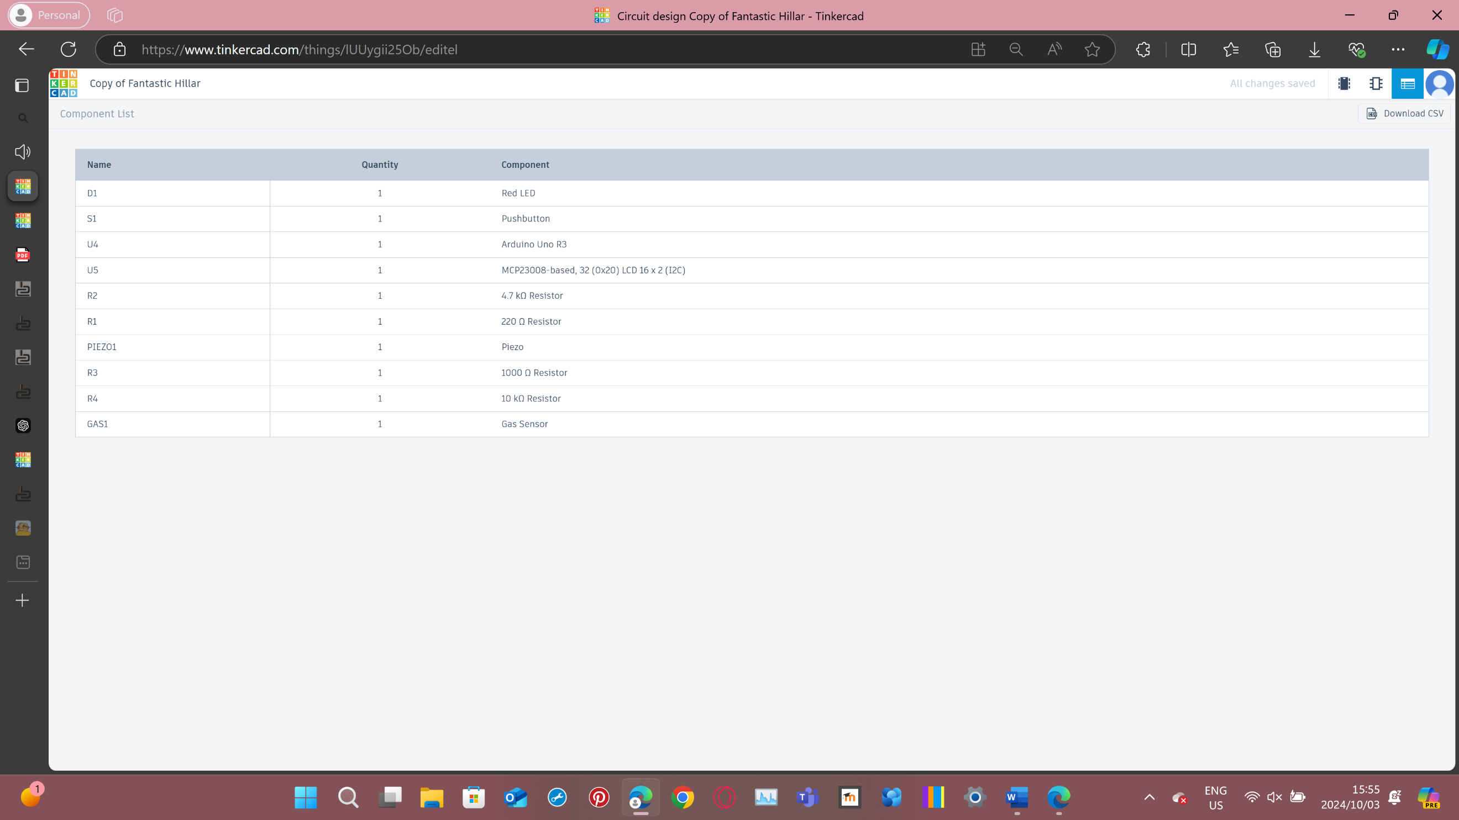

Circuit Design:

MQ-2 Gas Sensor: The analogue output pin (B) of the MQ-2 sensor is connected to an analogue input pin (A0) of the Arduino. This pin reads smoke levels.

Piezo Buzzer: The positive terminal of the buzzer is connected to digital output pin D12, and the negative terminal to GND.

Red LED: The anode of the LED is connected to digital output pin D13, and the cathode is connected to GND via a resistor.

Pushbutton: One terminal of the pushbutton is connected to digital input pin D2, and the other terminal to GND.

16x2 LCD Display: Connected via I2C communication with the SDA and SCL pins connected to A4 and A5, respectively.

Power Supply: The Arduino provides 5V power to all components, with all GND pins connected to a common ground.

Operation:

The smoke detection system continuously monitors smoke levels using the MQ-2 sensor. When the sensor detects smoke levels above a predefined threshold, the system activates the buzzer and flashes the red LED to alert the user. The LCD displays the current status, either "System OK" or "Smoke Detected." The user can press the pushbutton to reset the system, silencing the alarm and resetting the LED and LCD.

### Schematic view:

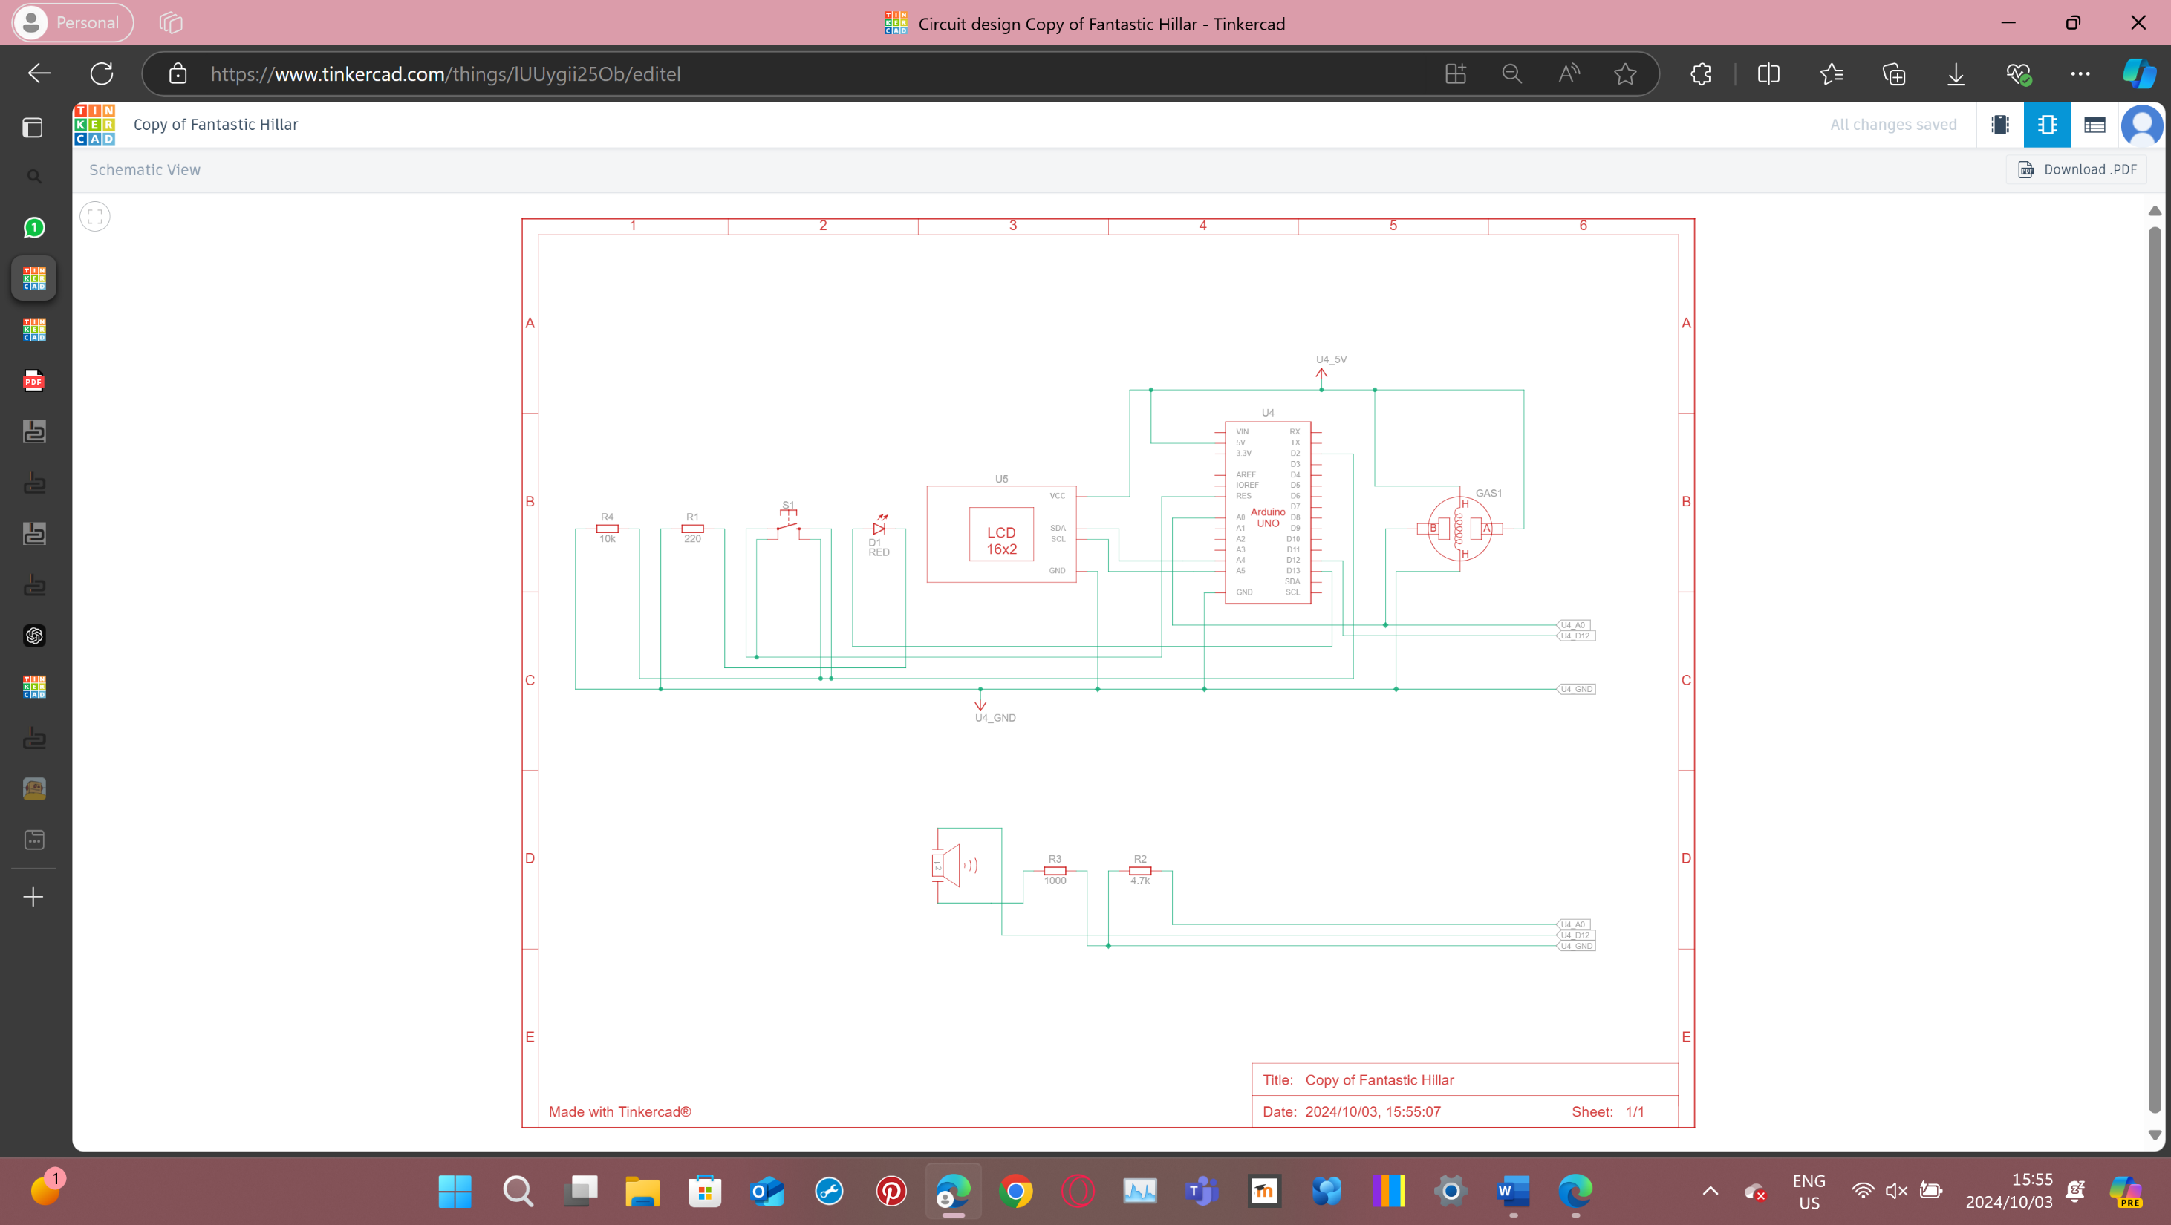

The schematic diagram includes the following key connections:

* MQ-2 sensor connected to A0.
* Buzzer connected to D12.
* Red LED connected to D13 with a current-limiting resistor.
* Pushbutton connected to D2 and GND.
* LCD connected via I2C to A4 and A5.

The smoke detection system provides an efficient method to detect hazardous smoke levels. It combines visual, auditory, and textual feedback mechanisms to ensure that users are quickly alerted in the event of danger. Future enhancements could include additional sensors for detecting other hazardous gases or integrating a temperature sensor.

# Task 2: Human detection probe

## Arduino sketch:

* System off.

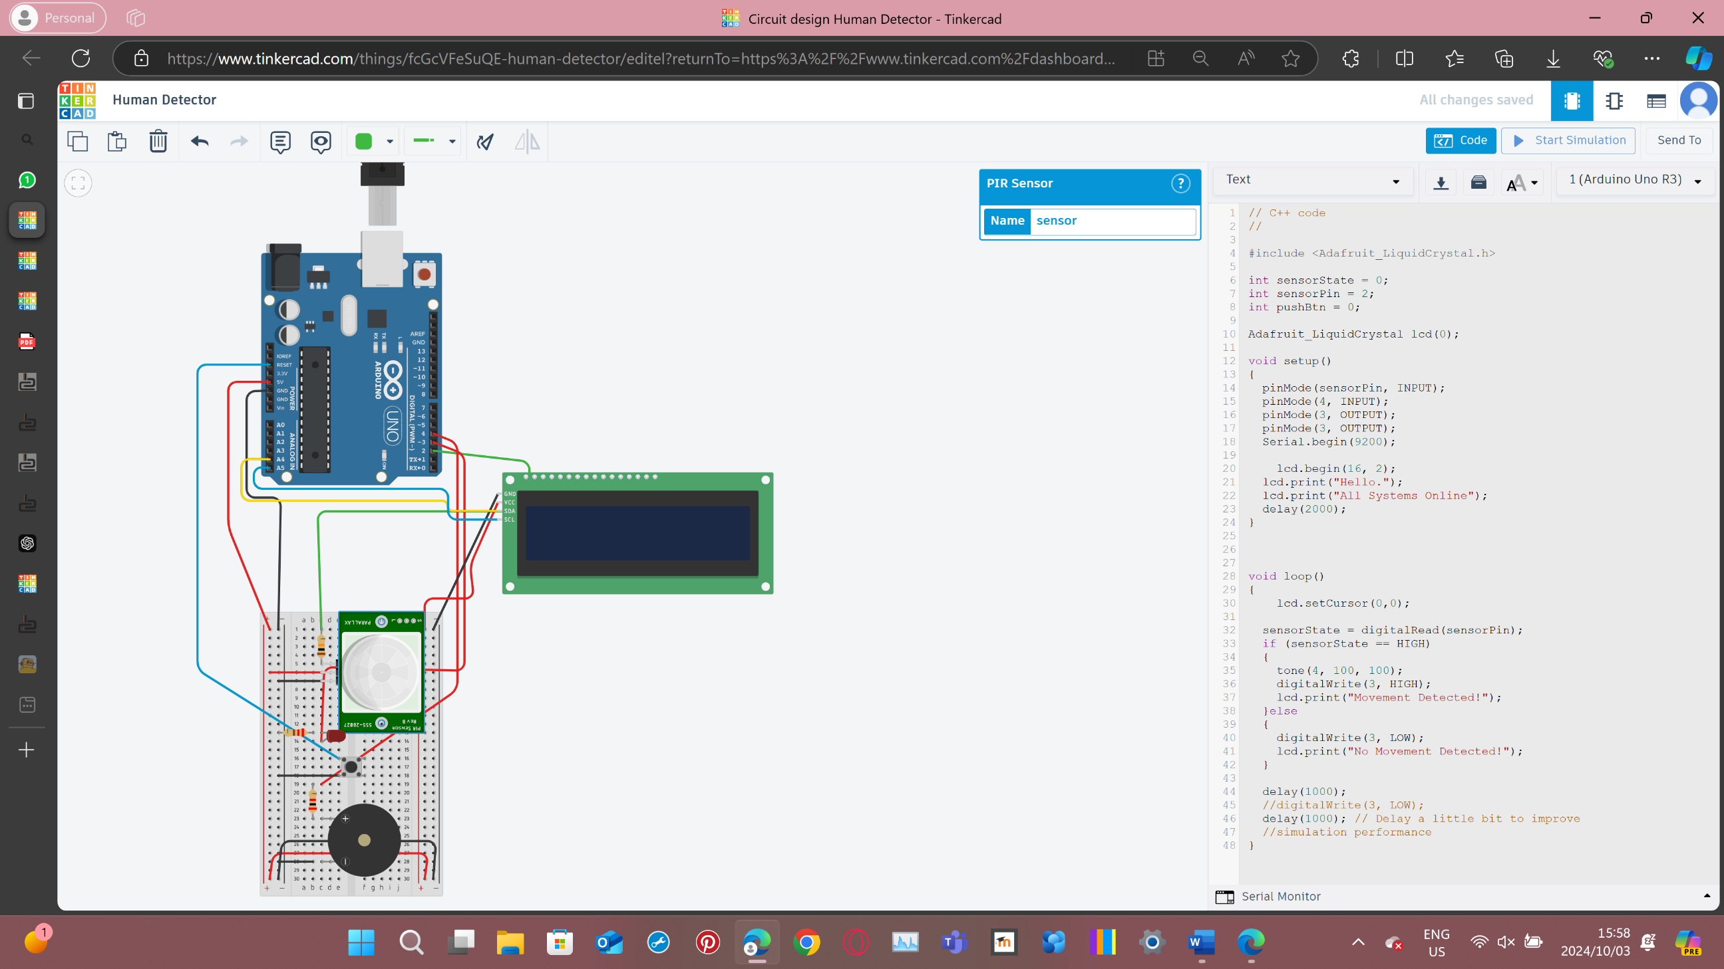

* System on.

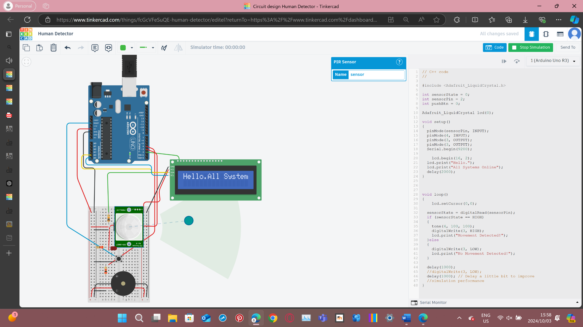

* System on.

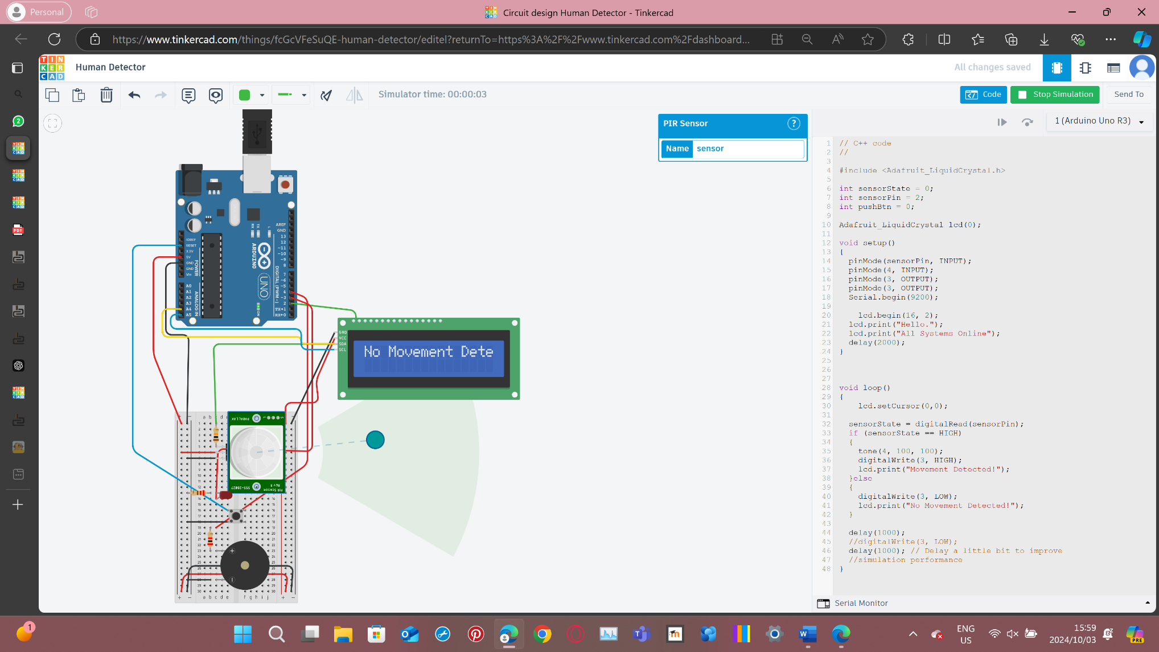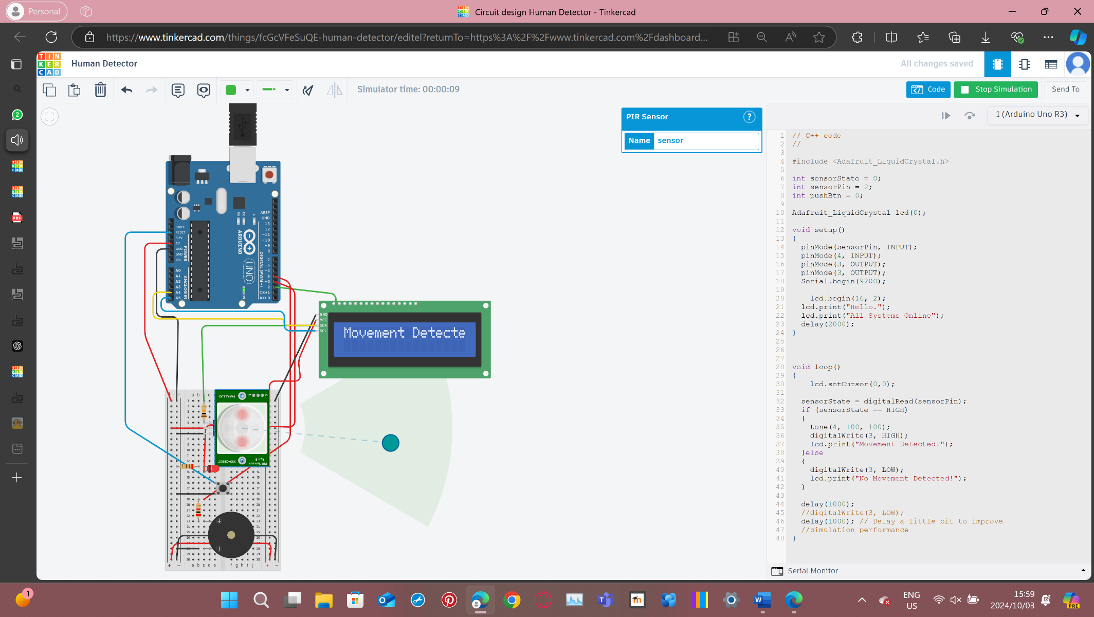

* System code.

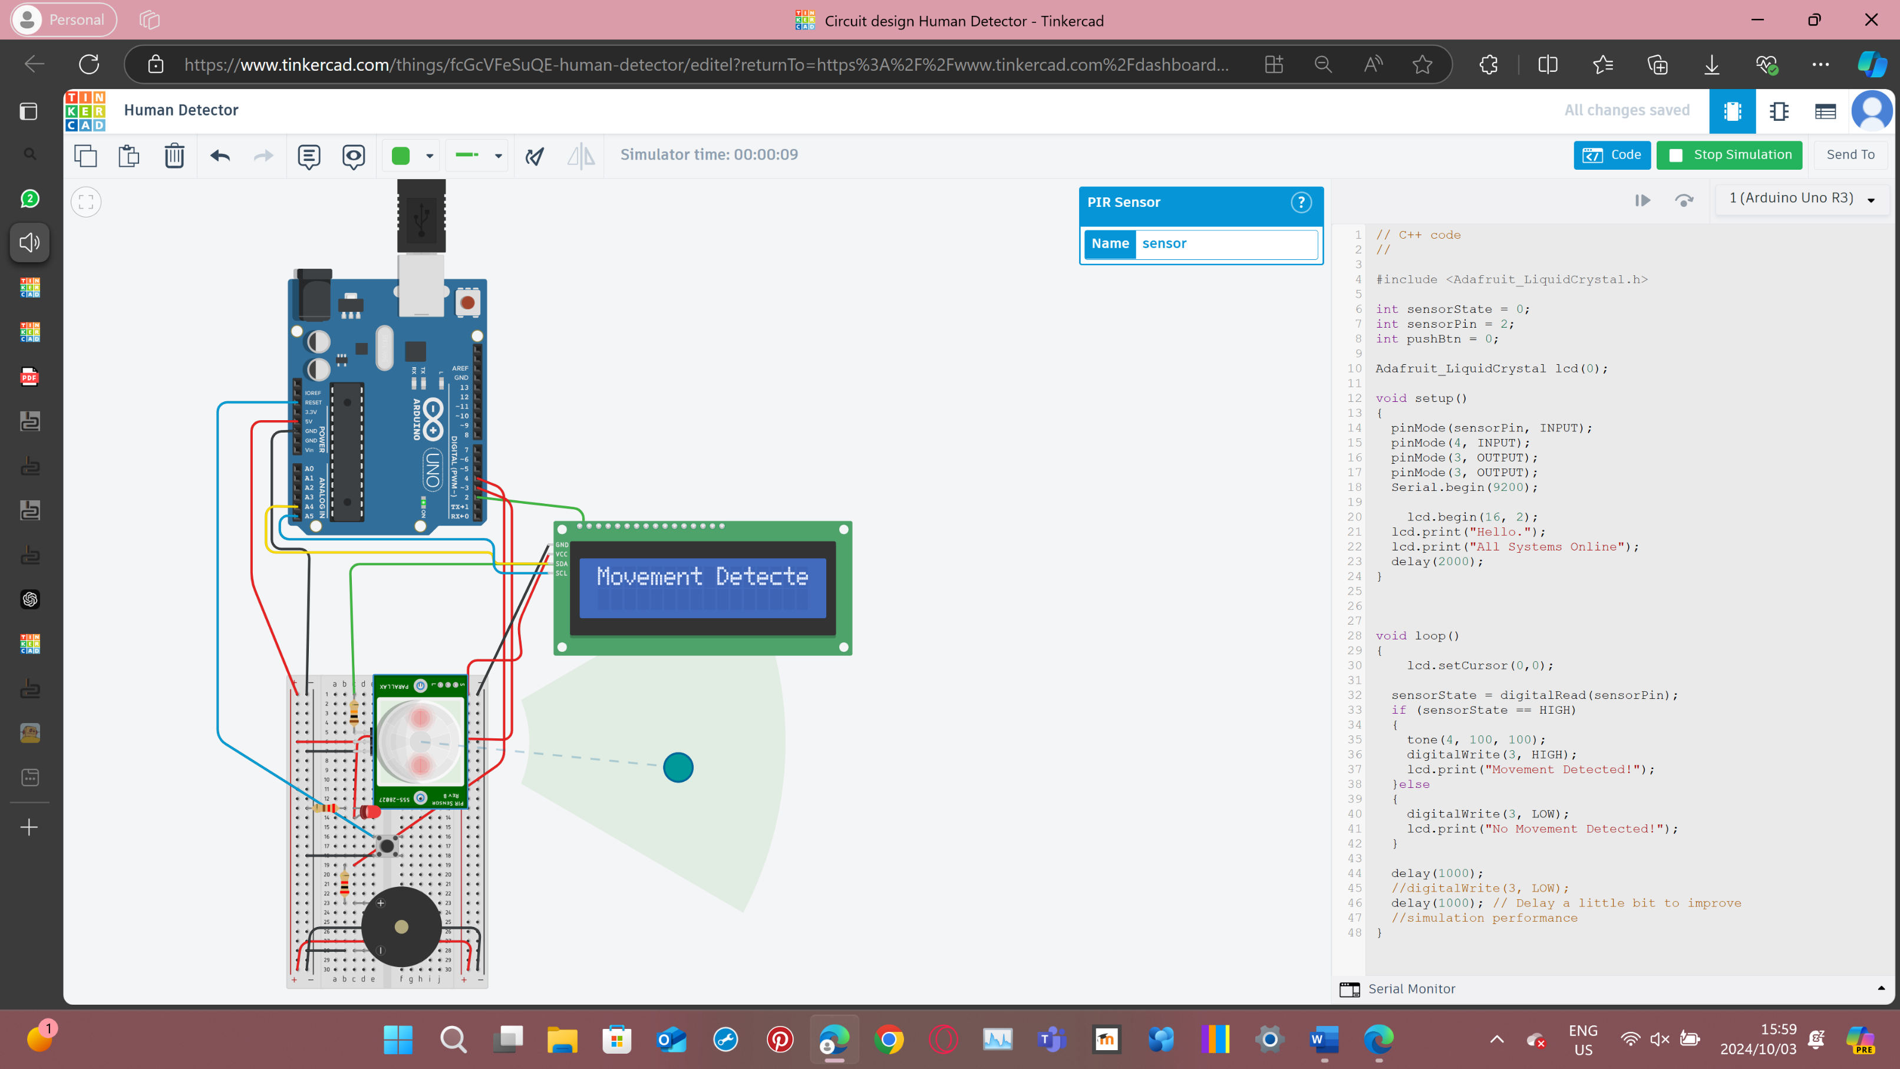

## Technical Report for Task 2: Human Detection Probe

The human detection probe is designed to assist in search and rescue operations following an earthquake. The system uses a PIR sensor to detect the presence of humans under debris. When human movement is detected, the system triggers an alarm using a piezo buzzer and flashes a red LED. The status of the system is communicated on a 16x2 LCD display, and a reset mechanism is included via a normally open pushbutton.

### Components used:

* Parallax 555-28027 PIR Sensor: Detects human movement.
* Piezo Buzzer: Provides an audible alert when a human is detected.
* Red LED: Flashes when human movement is detected.
* 16x2 LCD Display: Displays the system status.
* Normally Open Pushbutton: Resets the system after an alarm is triggered.
* Resistors: Current limiting resistors for the LED.
* Arduino Uno: Microcontroller that controls the system.

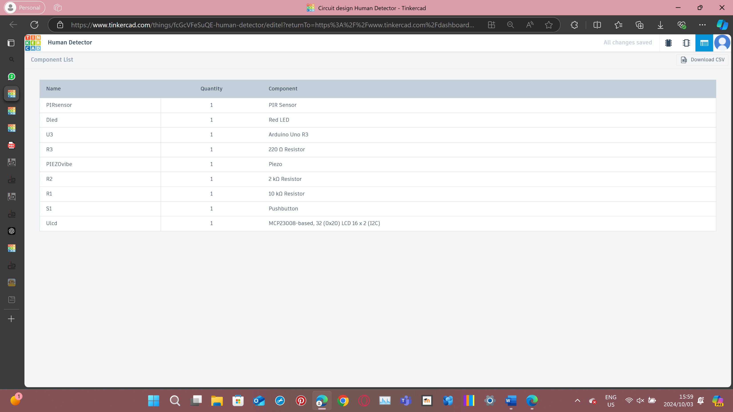

Circuit Design:

PIR Sensor: The signal pin of the PIR sensor is connected to digital input pin D2 of the Arduino. This sensor will detect human presence based on motion.

Piezo Buzzer: The positive pin is connected to digital output pin D4, and the ground is connected to GND.

Red LED: The anode of the LED is connected to digital output pin D3, and the cathode is connected to GND through a resistor.

Pushbutton: One terminal is connected to digital input pin RES, and the other to GND.

16x2 LCD Display: Connected via I2C communication with SDA and SCL pins connected to A4 and A5.

Power Supply: The Arduino provides 5V power to all components.

Operation:

The PIR sensor continuously monitors the area for human movement. When movement is detected, the buzzer and LED are activated, signalling that a human presence has been detected. The LCD displays the current status as either "No movement detected" or "Movement Detected." The system remains in alert mode until the user presses the pushbutton to reset the system, stopping the alarm and resetting the LED and LCD.

### Schematic view:

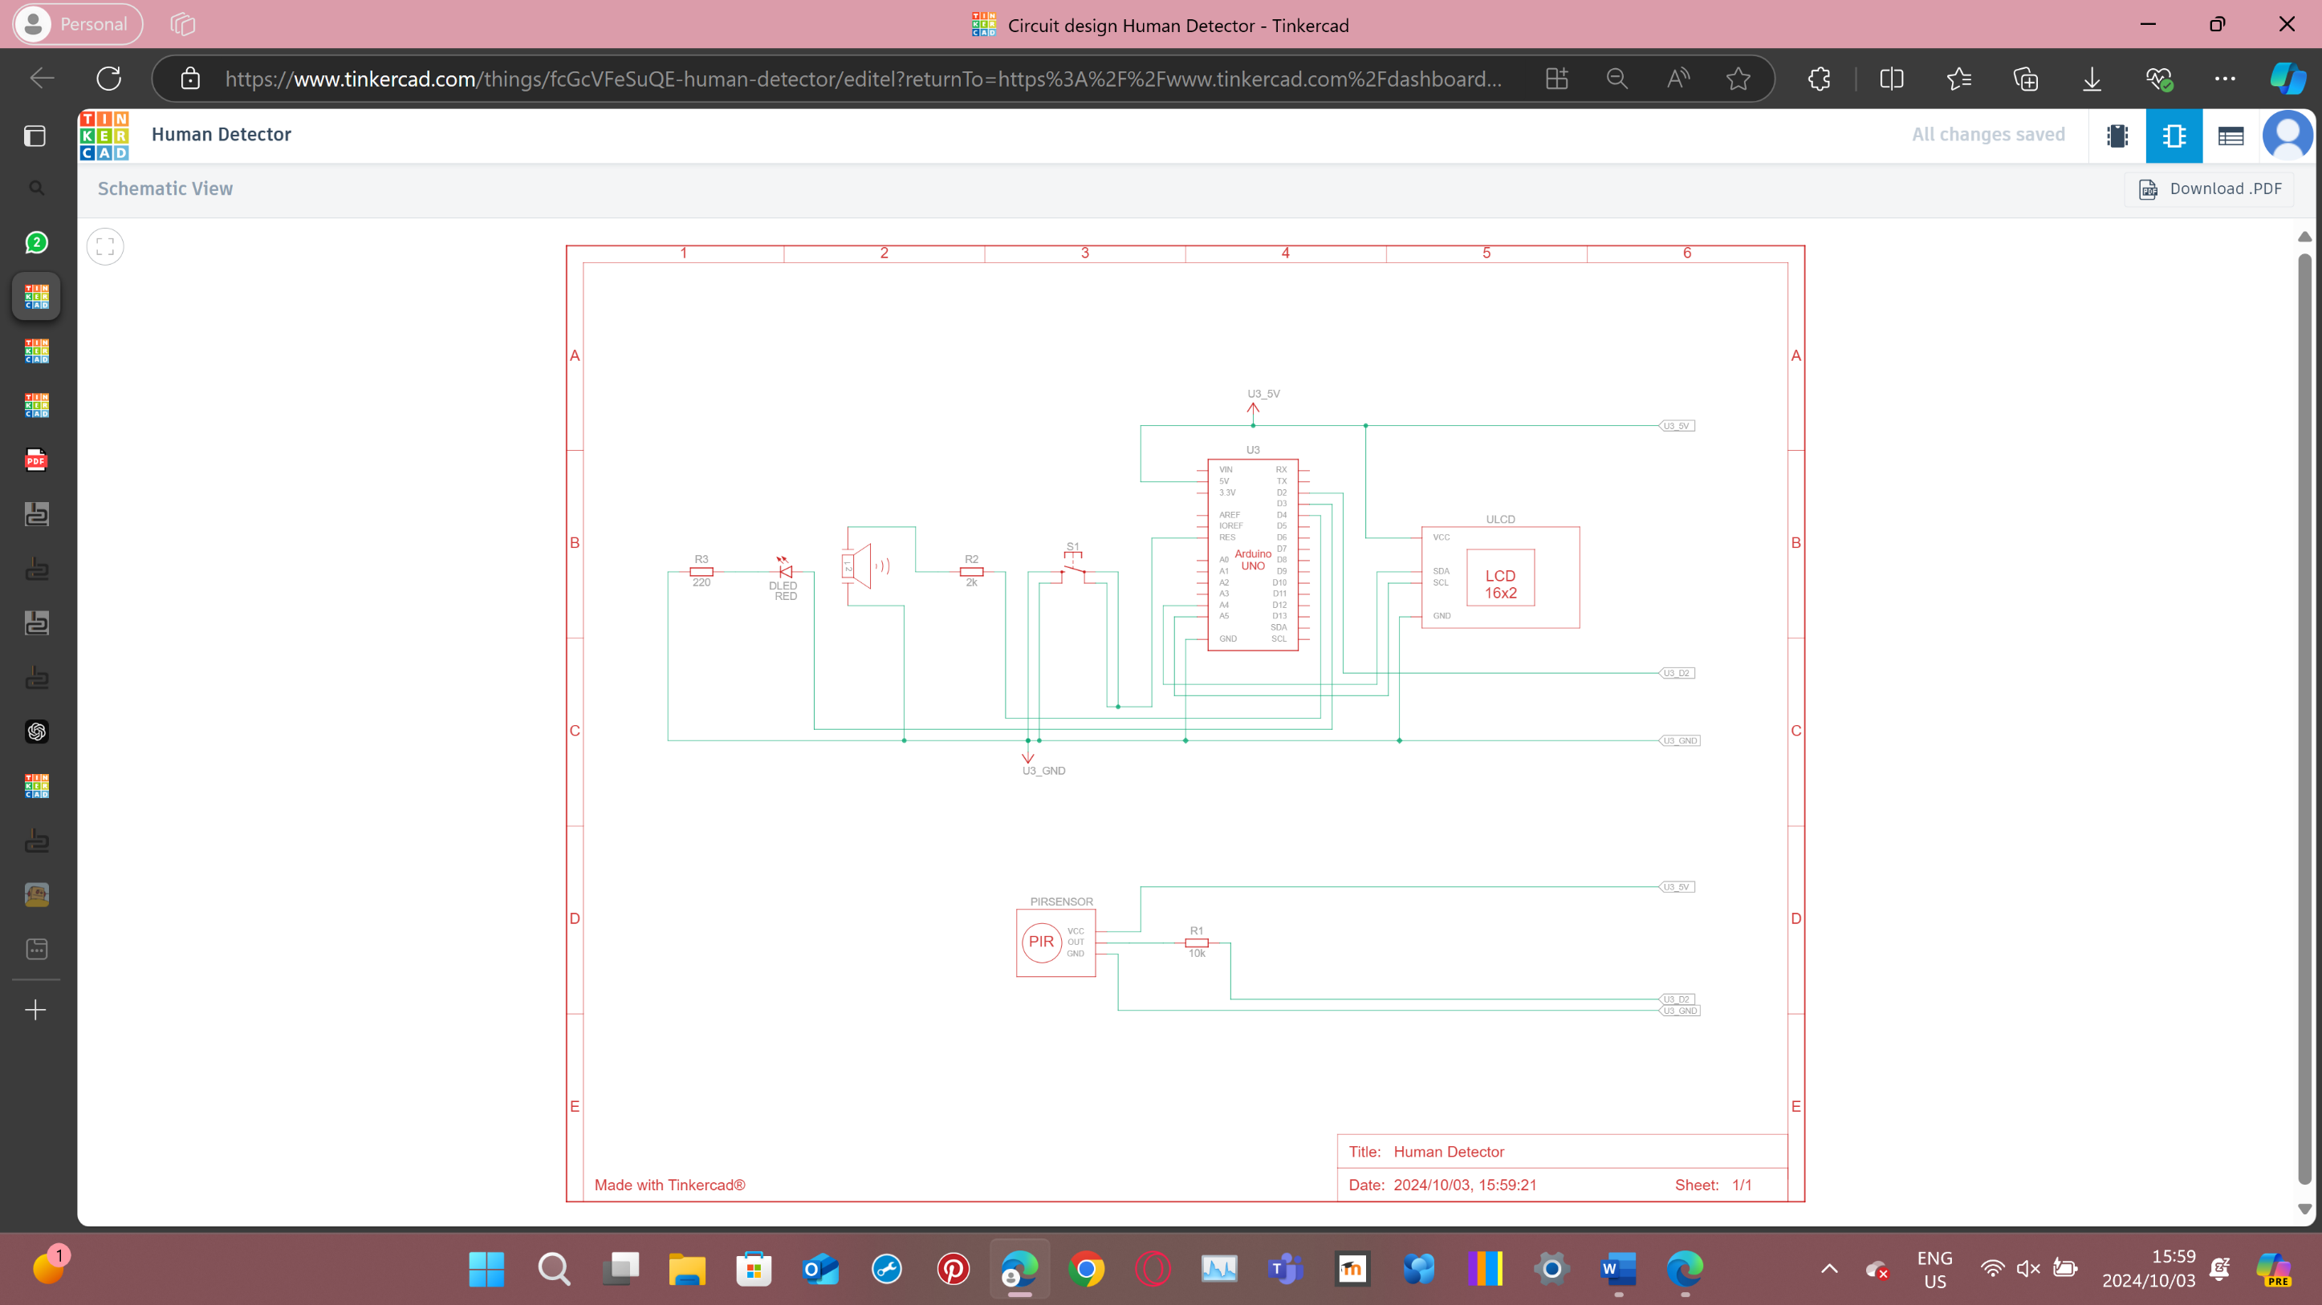

The schematic for the human detection probe includes the following connections:

* PIR sensor signal pin to D2.
* Buzzer connected to D4.
* Red LED connected to D3 with a current-limiting resistor.
* Pushbutton connected to RES and GND.
* LCD connected via I2C to A4 and A5.

The human detection probe is a practical solution for search and rescue scenarios, enabling quick detection of humans buried under debris. The system efficiently alerts rescuers to human presence using a combination of audible, visual, and textual alerts. In future developments, more advanced sensors, or wireless transmission of alerts to rescue teams could be added to enhance the system's usability.